**Title of the paper, (ALL CAPITAL IN Times NEW Roman Size 14)**

Author 1,a Author 2b, Author 3c

a *Address,.* b*Address,* c *Address*

E-mail: email@institution.extension

(Underline presenting author)

**Keywords:** At least four keywords must be included

**The subtitles should be bold all CAPS and in Times New Roman with font size 12.**

The text should be in Times New Roman with font size 11. Spacing between the lines should be 1.

**INTRODUCTION** **(Bold Font 12)**

(Font size 11) Brief introduction giving details of the background, rationale and need for undertaking such study.

**METHODS (Bold Font 12)**

(Font size 11)Discuss experimental or theoretical methods employed for the present investigation**.**

**RESULTS AND DISCUSSION (Bold Font 12)**

(Font size 11) Give details of the observations/data/calculations. Explain the results clearly. This passage should give an excellent summary of the research/application that will be presented in the conference. Please also include references to your workand general citations. For the references use the format given below. References should be quoted in text within brackets as [1]

**The entire contents of the abstract should not exceed two pages, including figure/tables, if space allows. Figures and Tables should be provided with all the necessary details. Unlabelled figures and tables will not be accepted.**

**Table 1. Caption heading for a table should be placed at the top of the table and within table width.**

**(**Use “time news roman” font, size 11pt, No spacing after table title)

|  |  |  |  |  |
| --- | --- | --- | --- | --- |
|  | **A** | **B** | **C** | **D** |
|  |  |  |  |  |
| **A** | Aa | Ab | Ac | Ad |
| **B** | Ba | Bb | Bc | Bd |
| **C** | Ca | Cb | Cc | Cd |
| **D** | Da | Db | Dc | Dd |
| **E** | Ea | Eb | Ec | Ed |
|  |  |  |  |  |

Fig.1: Experimental Program.

a) Thermocouple arrangement

b) Test Facility

c) Result

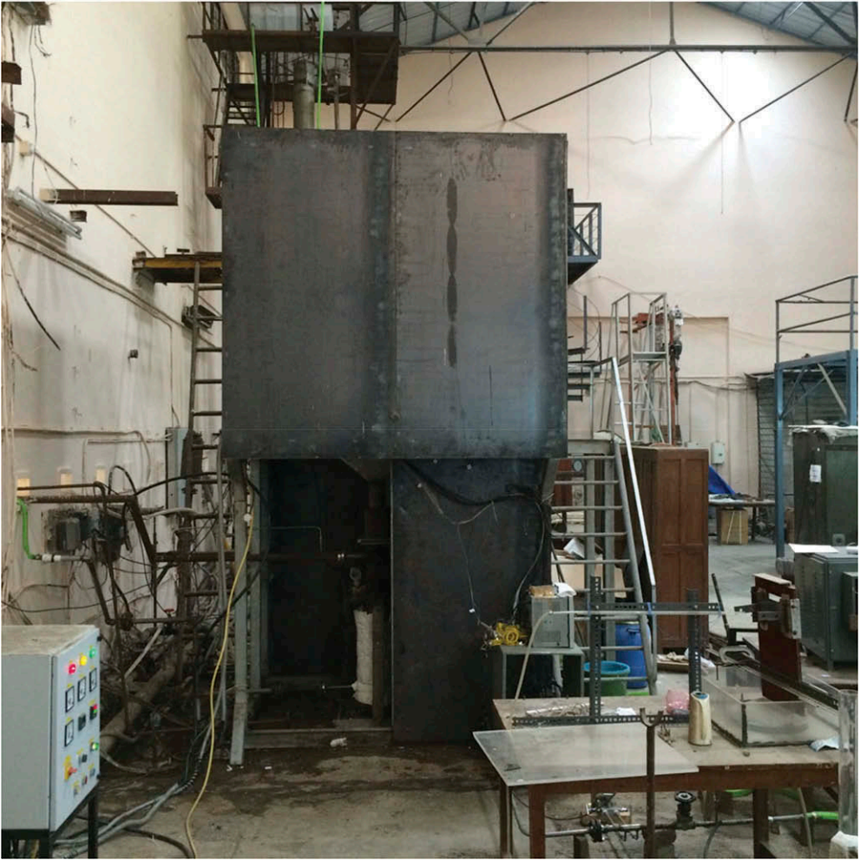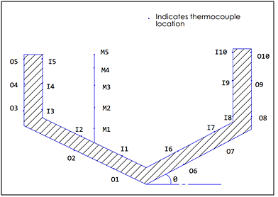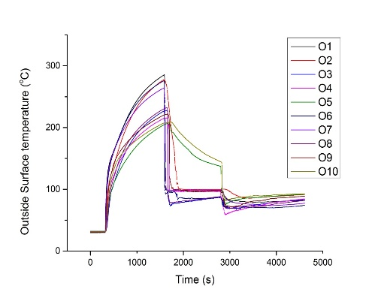

**CONCLUSIONS (****Bold Font 12)**

(Font size 11) Give one or two lines of conclusions of the research paper. It should clearly give the outcome of work with possible future applications.

**REFERENCES (Bold Font 12)**

(Font size 11)

[1] B. R. Sehgal et al., “Experiments on In-Vessel Melt Coolability in the EC-FOREVER Program,” Nucl. Eng. Des.,236, 2199 (2006).

[2] B. R. Sehgal, “Stabilization and Termination of Severe Accidents in LWRs,” Nucl. Eng. Des.,236, 1941 (2006).